x86 Assembly Worksheet #28a Name _____________________________

Character Codes

Standard Character Codes
Most of the characters that can be typed are represented by standard character codes.
Below is a table of all such codes.

  0 | 1 | 2 | 3 | 4 | 5 | 6 | 7 | 8 | 9 | A | B | C | D | E | F
 | 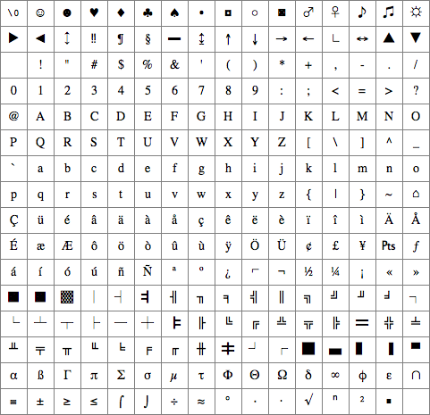
  0
  1
  2
  3
  4
  5
  6
  7
  8
  9
  A
  B
  C
  D
  E
  F

To obtain the standard character code of a character in the table, locate the cell that contains the character:
- The high-nibble of the code is the hexadecimal digit corresponding to the row that the cell is in.
- The low-nibble of the code is the hexadecimal digit corresponding to the column that the cell is in.

For example, the character code of the question mark (?), whose cell is in row 3 and column F, is 3Fh.
(The h indicates that 3F is a hexadecimal number.)
x86 Assembly Worksheet #28b Name _____________________________
Revised 7/1/2005
Character Codes (continued)

Control Codes
The first 32 standard character codes are designated as control codes. Many control codes cause special actions when they are printed. Below is a table of the more useful control codes:

Standard Code | Name | Special Action
00h | Null | No action.
07h | Bell | Generates a beep.
08h | Backspace | Moves the cursor left one column.
09h | Tab | Types six spaces, moving the cursor right six columns.
0Ah | Line Feed | Moves the cursor down one row.
0Dh | Return | Moves the cursor to the first column of the present row.
1Bh | Escape | No action.

Extended Character Codes
Some of the less common characters are represented using extended character codes.
Below is a table of all such codes:

Extended Code | Key Sequence
03h | CTRL @
0Fh | SHIFT Tab
10h - 19h | ALT Q, W, E, R, T, Y, U, I, O, P (second row)  Exercises:  - Write a program that makes the computer generate a beep by printing a character.  Hint: Look in the table of  control codes for a  character that generates  a beep as its special action.  - Write a program that displays the following, without printing any spaces:  National  Computer  Camp  Hint: Look for a control code  that moves the cursor  down one row.
1Eh - 26h | ALT A, S, D, F, G, H, J, K, L (third row)
2Ch - 32h | ALT Z, X, C, V, B, N, M (fourth row)
3Bh - 44h | F1 - F10 function keys
47h | Home
48h | ⇑ (Up Arrow)
49h | PgUp (Page Up)
4Bh | ⇐ (Left Arrow)
4Dh | ⇒ (Right Arrow)
4Fh | End
50h | ⇓ (Down Arrow)
51h | PgDn (Page Down)
52h | Ins (Insert)
53h | Del (Delete)
54h - 5Dh | SHIFT F1 - F10
5Eh - 67h | CTRL F1 - F10
68h - 71h | ALT F1 - F10
72h | CTRL Print Screen (F13)
73h | CTRL ⇐ (Left Arrow)
74h | CTRL ⇒ (Right Arrow)
75h | CTRL End
76h | CTRL PgDn (Page Down)
77h | CTRL Home
78h - 83h | ALT 1, 2, 3, 4, 5, 6, 7, 8, 9, 0, –, = (first row)
84h | CTRL PgUp (Page Up)

